Event Husk Database Design
By Prem Vora

1. Business Idea (EventHusk):
EventHusk is designed as an all-in-one Campus Events and Facility Booking System tailored to the needs of students, clubs, and organizations at Northeastern University. With EventHusk, users can easily book event spaces like halls, studios, or other campus locations for private or club events. The platform provides a user-friendly interface for viewing available spaces, checking amenities, and scheduling events, allowing users to make informed booking decisions. Event support services, such as audiovisual setup or catering, can also be requested during the booking process, ensuring that event organizers have everything they need.
One of the key features of EventHusk is the ability to RSVP for events, allowing attendees to register and event organizers to track participation in real time. Additionally, users can leave feedback specific to the event spaces, helping improve the quality and management of facilities over time. This feedback system is invaluable for campus administrators, as it provides direct insight into the usability and satisfaction of each event space. As an added layer of future scalability, EventHusk will include a feature to display all upcoming events across campus, making it easier for students and organizations to plan their events efficiently, avoid scheduling conflicts, and attend activities that match their interests.
This system streamlines the process of campus event planning, optimizes space utilization, and fosters a collaborative and well-organized campus community.

2. Identifying Nouns and Verbs:
Nouns, Verbs

Nouns:
- EventHusk
- Events
- Facilities
- Booking System
- Students
- Clubs
- Organizations
- Users
- Halls
- Studios
- Locations
- Private
- Clubs
- Amenities
- Support
- Audiovisual Setup
- Catering
- Organizers
- RSVP
- Feedback
- Quality
- Management
- Administrators

Verbs:
- Easily book
- Viewing
- Checking
- Scheduling
- Inform
- Request
- Allow
- Track
- Participate
- Improve
- Usability
- Satisfaction
- Display
- Easier
- Plan
- Efficiently
- Attend
- Planning
- Optimizes
- Utilization
- Collaborative
- Well-organized

3. Classifying Nouns and Verbs:

- Users
  - User ID
  - Username
  - Password
  - Name
  - Email
  - Contact
  - Role: “Attendee”, “Organizer”

- Events
  - Event ID
  - Event Name
  - Event Description
  - Date
  - Time
  - RSVP Deadline

- Venue Resources
  - Resource ID
  - Resource Type
  - Handler
  - Contact

- Venue
  - Venue ID
  - Venue Name
  - Capacity
  - Location
  - Policies
  - Availability Status
  - Person Responsible
  - Contact

- Event Feedback
  - User ID
  - Comments
  - Event ID

- RSVP
  - User ID
  - Event ID
  - Status
  - Link
  - Date and Time

4. Business Rules:

- There will be two types of accounts in this application. Attendees and Organizers.
- Those who are Attendees cannot book an event space while those who are organizers cannot RSVP or leave feedback for an event.
- Organizers can view all the available venues and then book the venue which fits their event.
- Each event can book multiple venues at the same time while each venue will host only one event at a single time.
- Venues will have certain resources available which provide an added insight into the space and users can make more informed decisions.
- Only one RSVP and one Feedback is allowed per user for a single event.
- Feedback can only be given by those who RSVP’d for the event. This way we can ensure that we get feedback from the people who attended the event.
- Each venue will have its own set of policies and capacity limits to give added insight to the users while booking.
- You can only RSVP before the deadline for the RSVP mentioned in the events table.

5. UML and ERD Diagram:

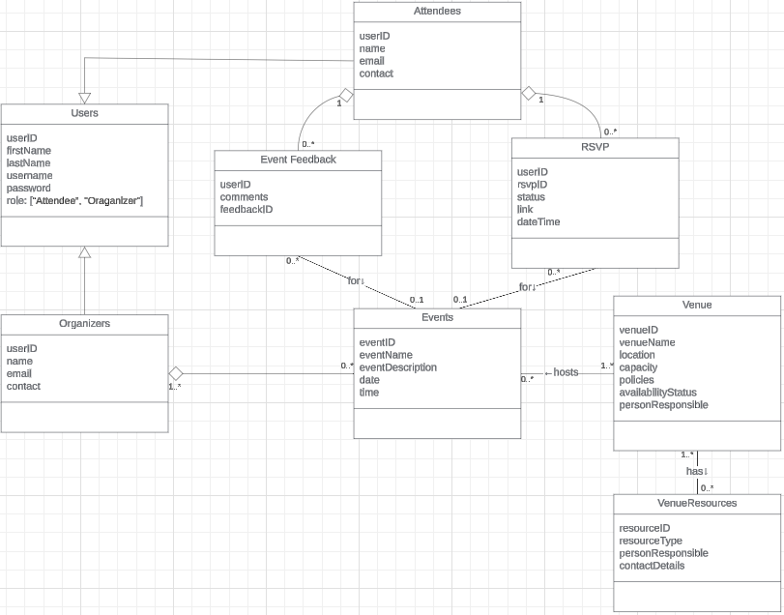

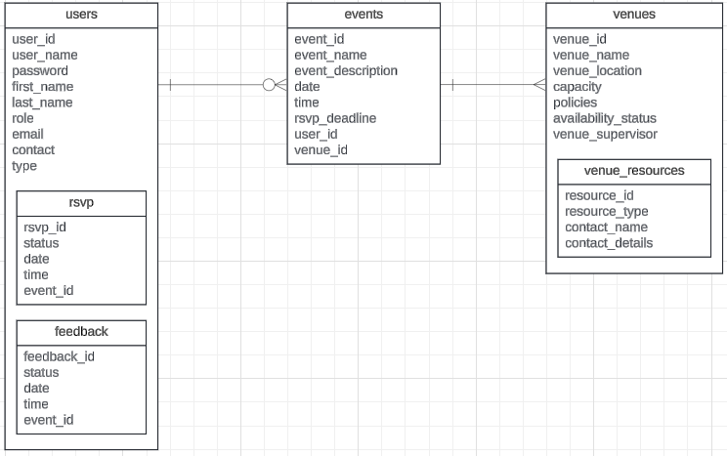
https://lucid.app/lucidchart/e87d0d37-0051-445c-b56a-8a39f9472a8e/edit?viewport_loc=-1035%2C-1256%2C6059%2C3252%2CHWEp-vi-RSFO&invitationId=inv_3bb97a86-dca6-474d-b830-e56cd566421b

6. :

